Tram Nguyen

CIS 450

Lab 5

Group 1

**SVB Financial Group**

**site:fortune.com inurl:svb financial group**

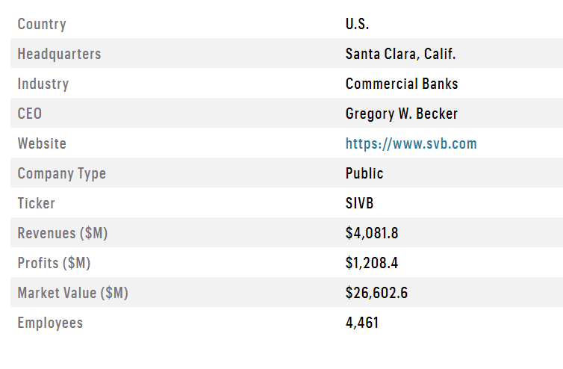

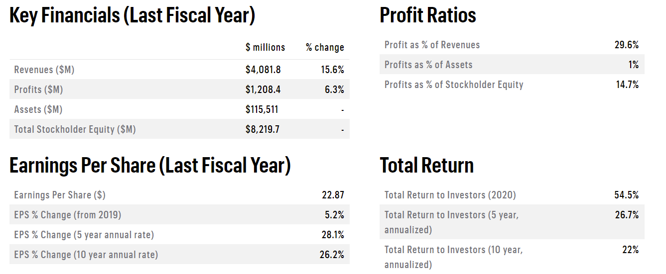

**Netcraft**

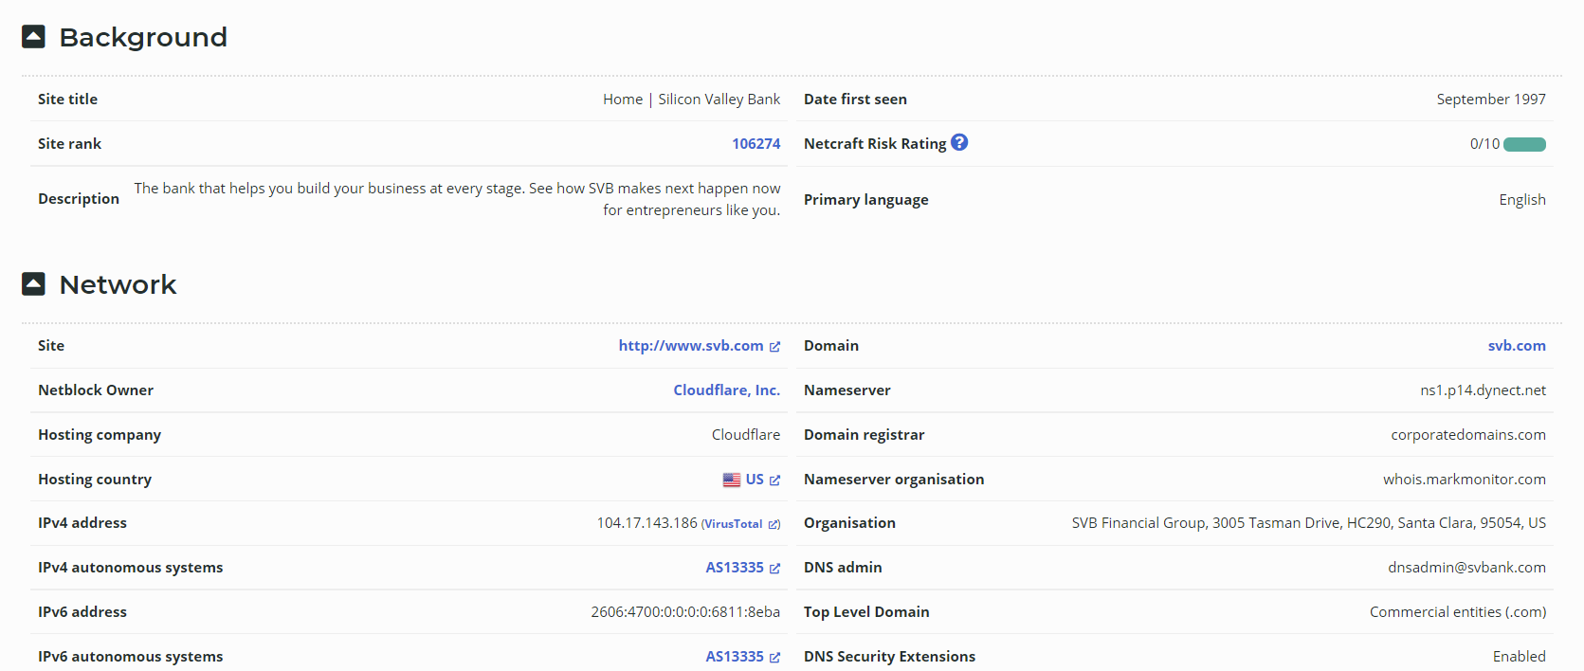

**Directors and Executive**

**inurl:svb financial group filetype:pdf**

<https://www.svb.com/globalassets/library/uploadedfiles/content/corporate/2020-annual-report-on-form-10-k.pdf>

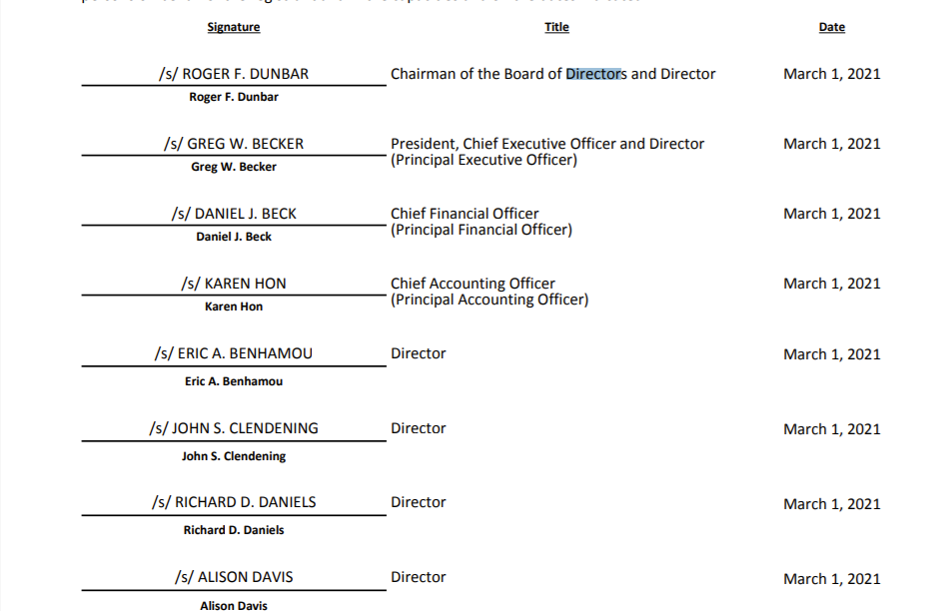



**Greg Becker – Chief Executive Officer**

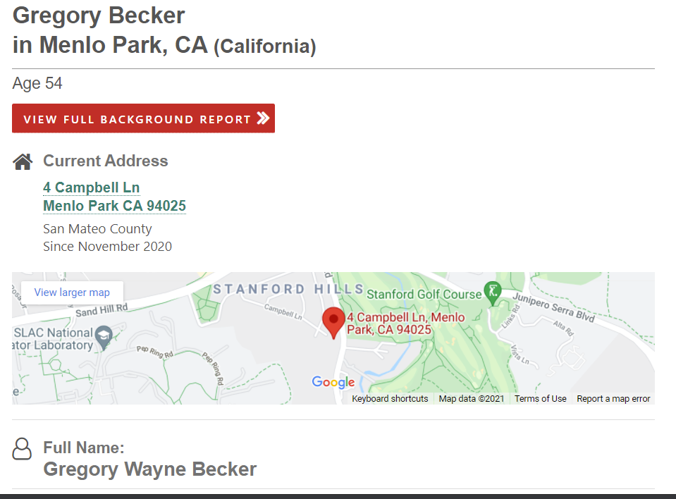

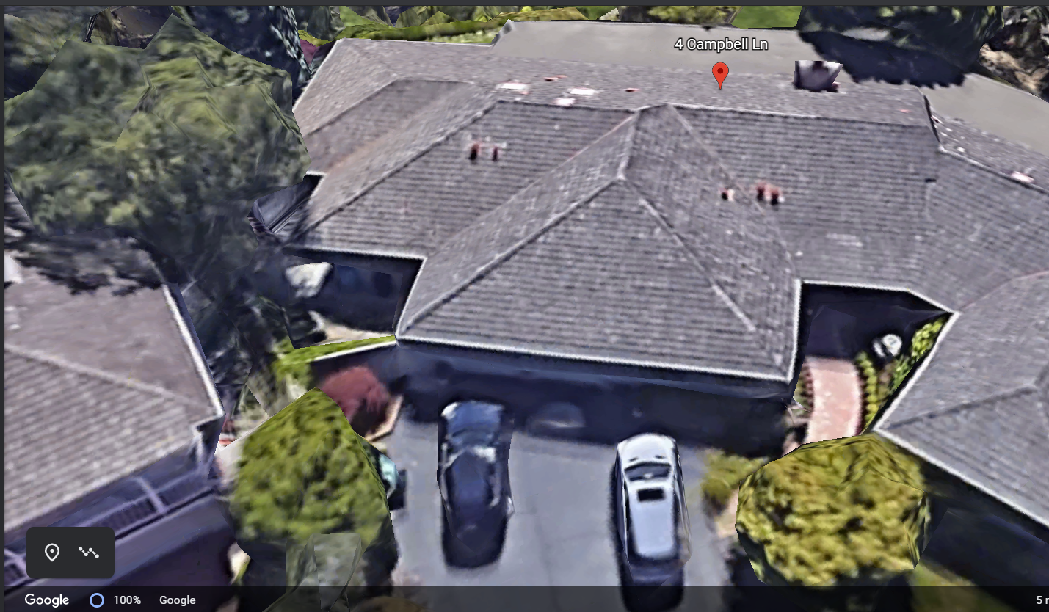

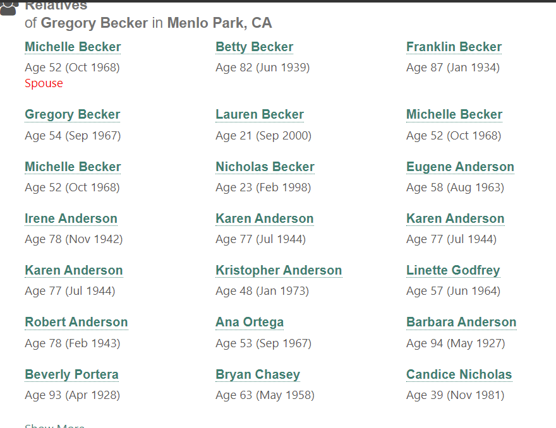

**Daniel J Beck**

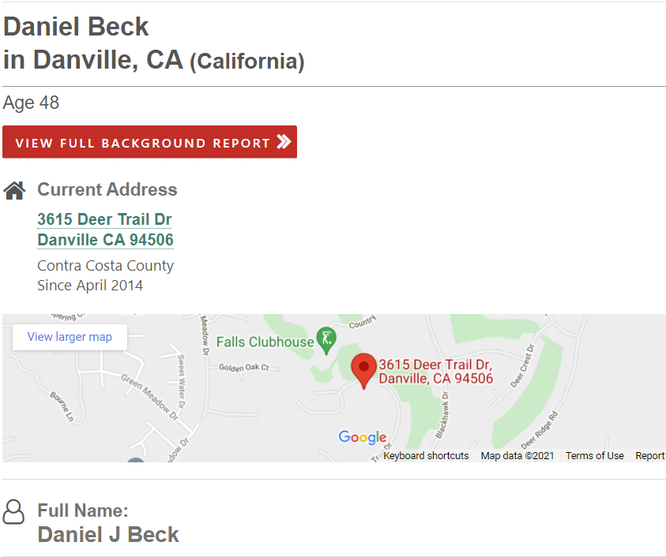

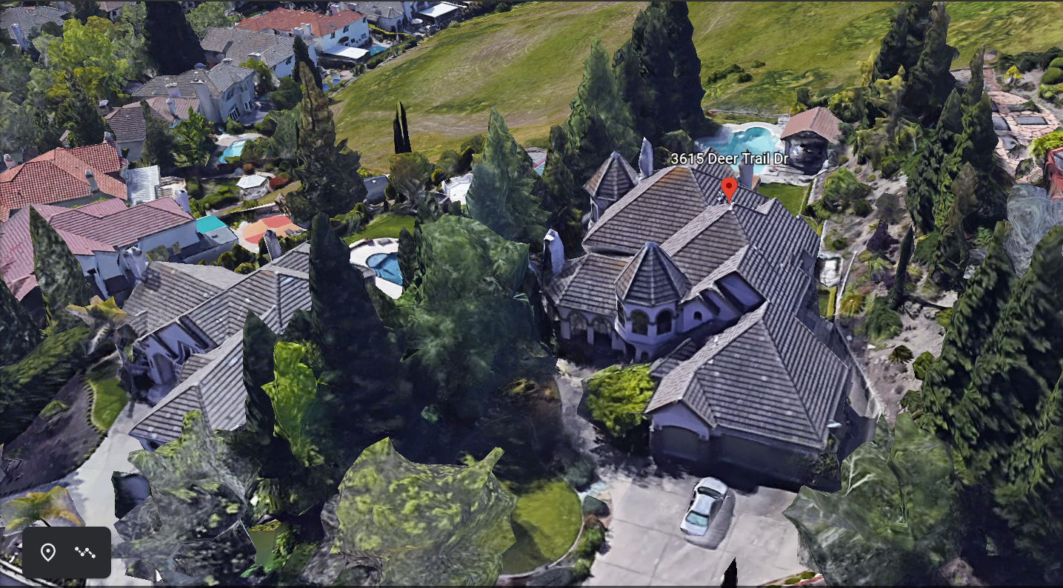

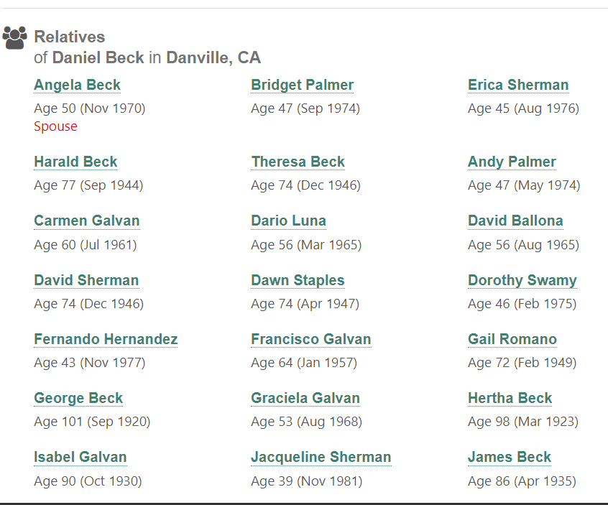

**SVB Financial Group**

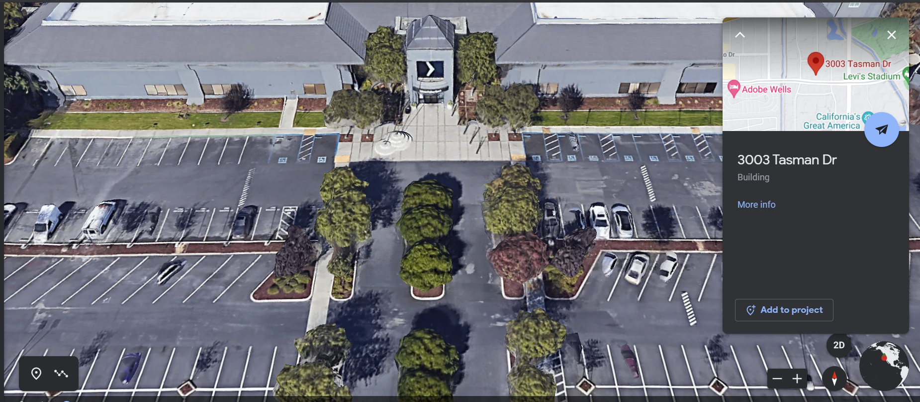

**Weibo**

**site:fortune.com inurl:weibo**

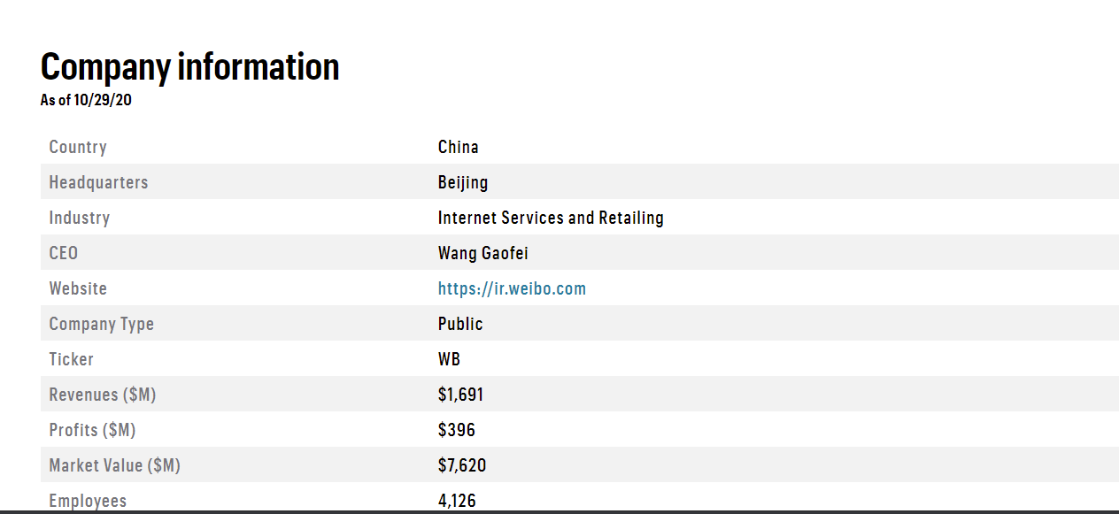

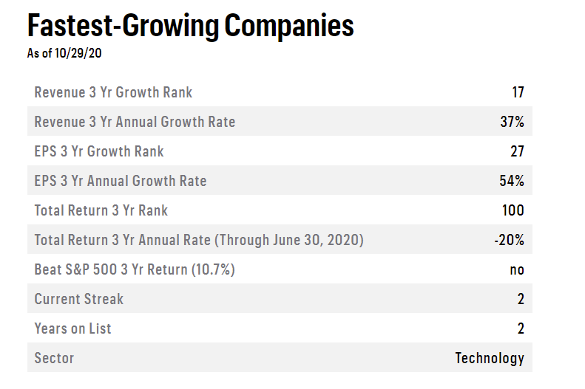

**Directors and Senior Management**

**site: weibo.com filetype:pdf**

http://ir.weibo.com/static-files/9537b1c6-da60-4bd4-8c66-9393d72ca7a3

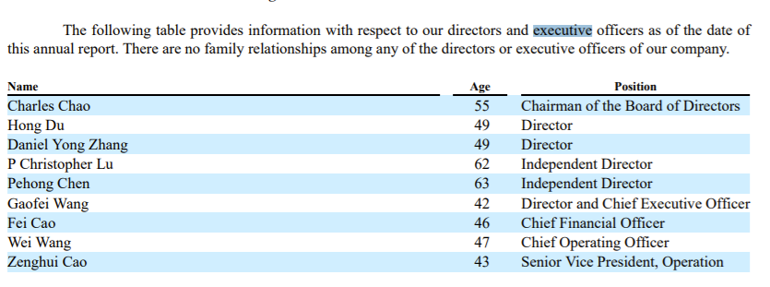

**Financial Data from 2014-2018**

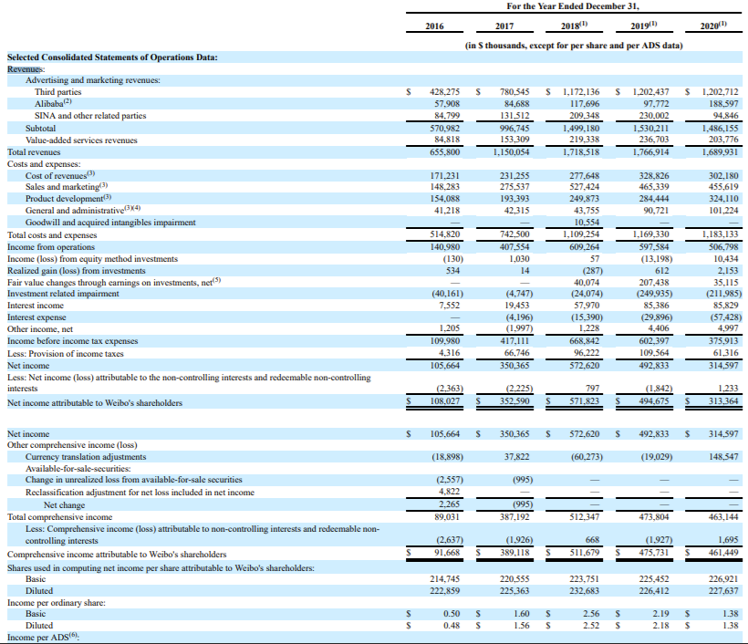

**Netcraft**

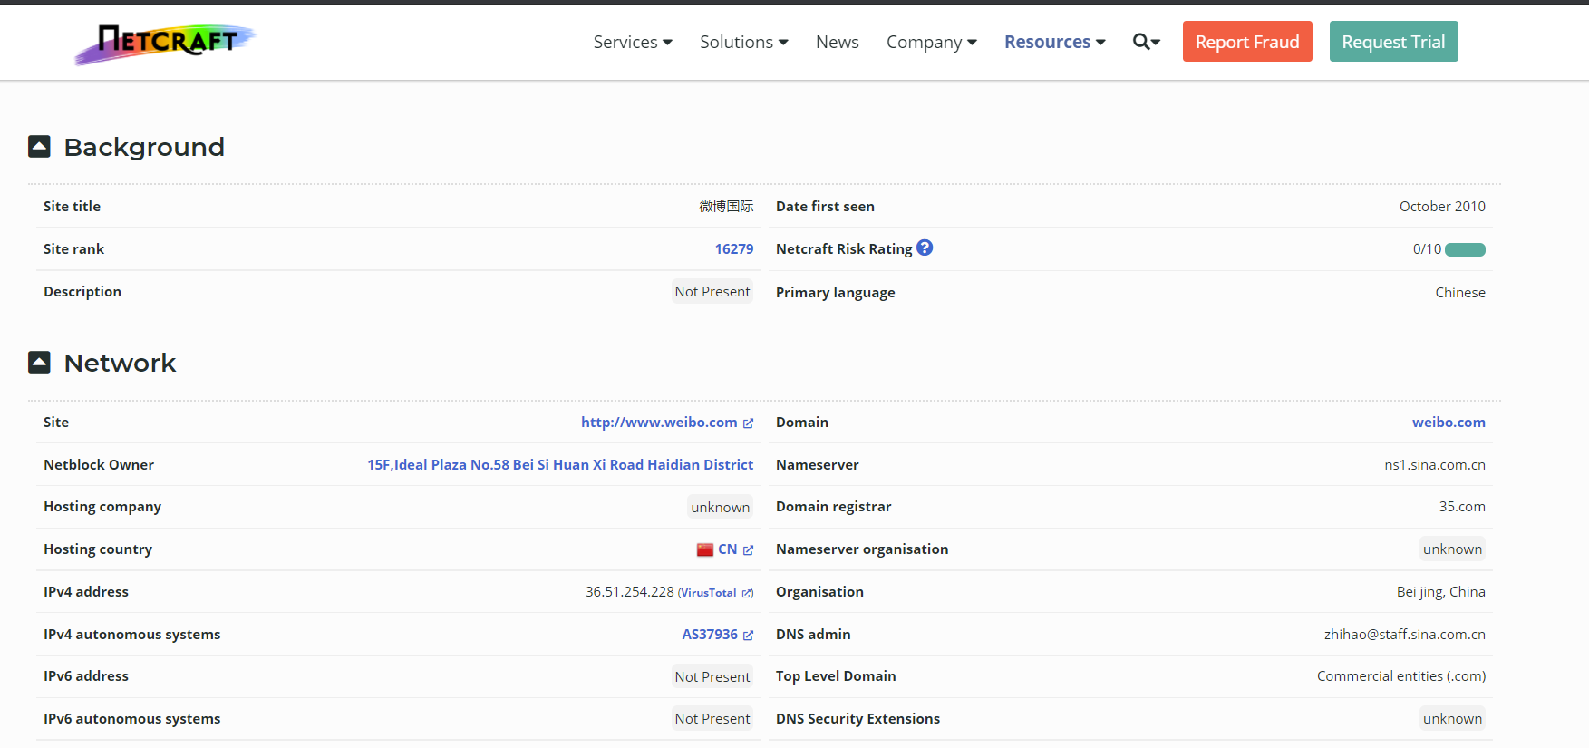

**Gaofei Wang**

**intitle:gaofei wang inurl:gaofei +intext:"phone"**

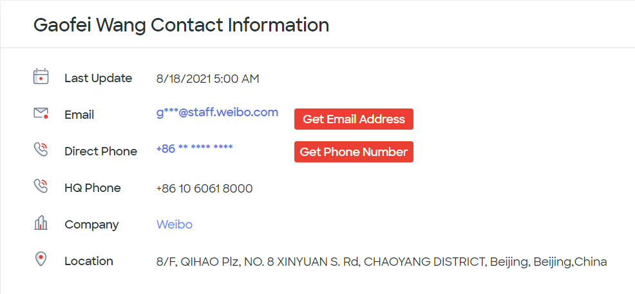

His weibo account

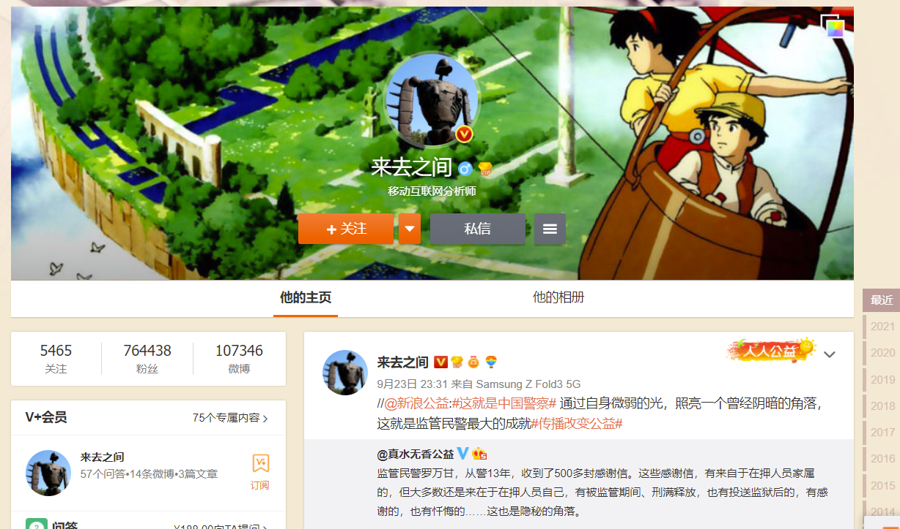

I cannot find his personal address and family information also because this private information cannot be leaked on public in China.

Image of Weibo office on Google Earth

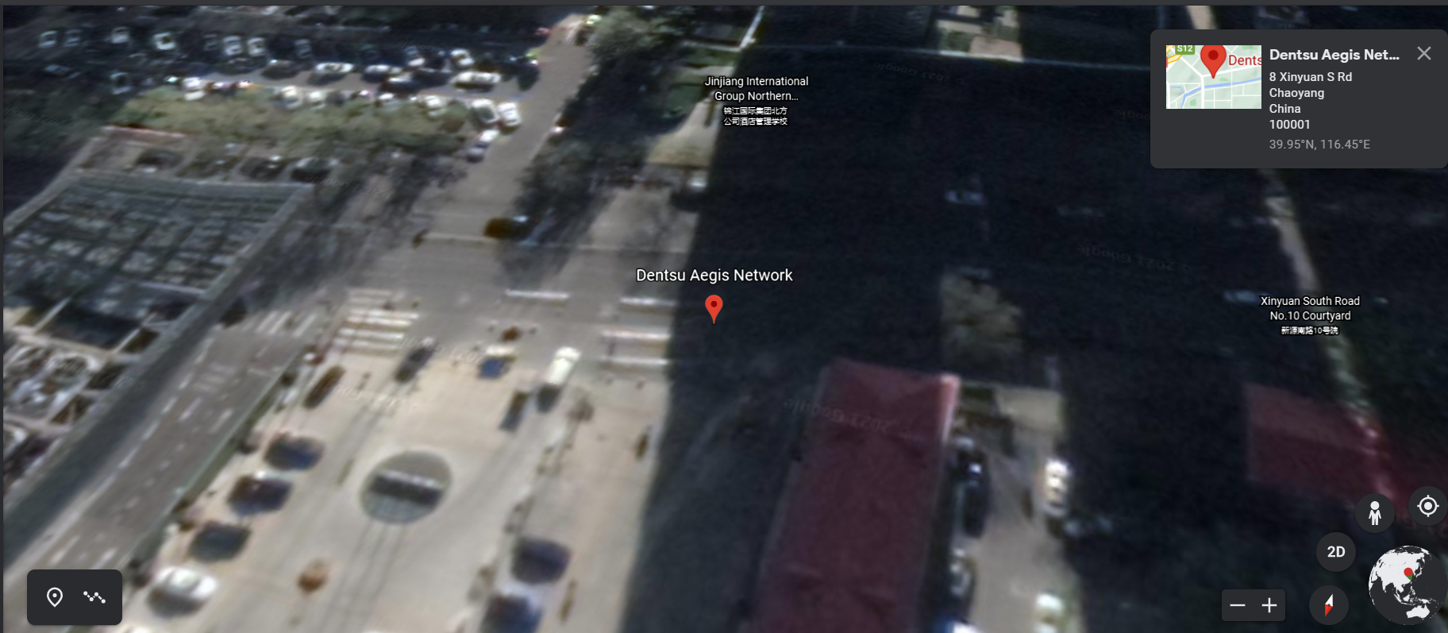

**Adobe**

**Site:fortune.com inurl:adobe**

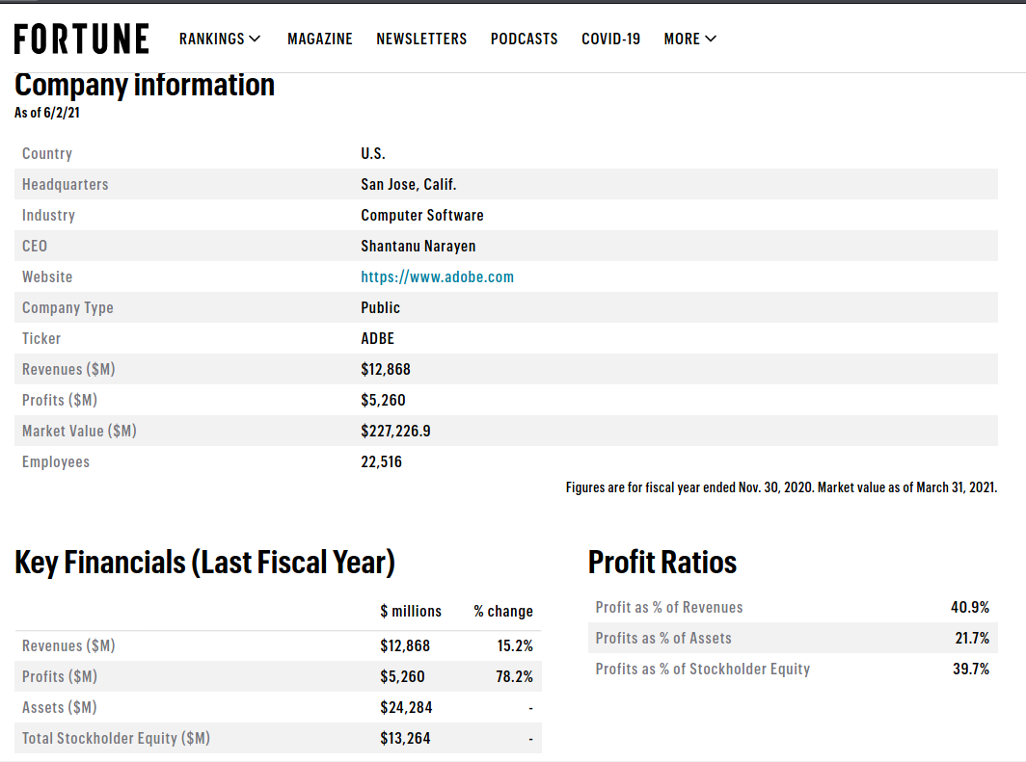

**Netcraft**

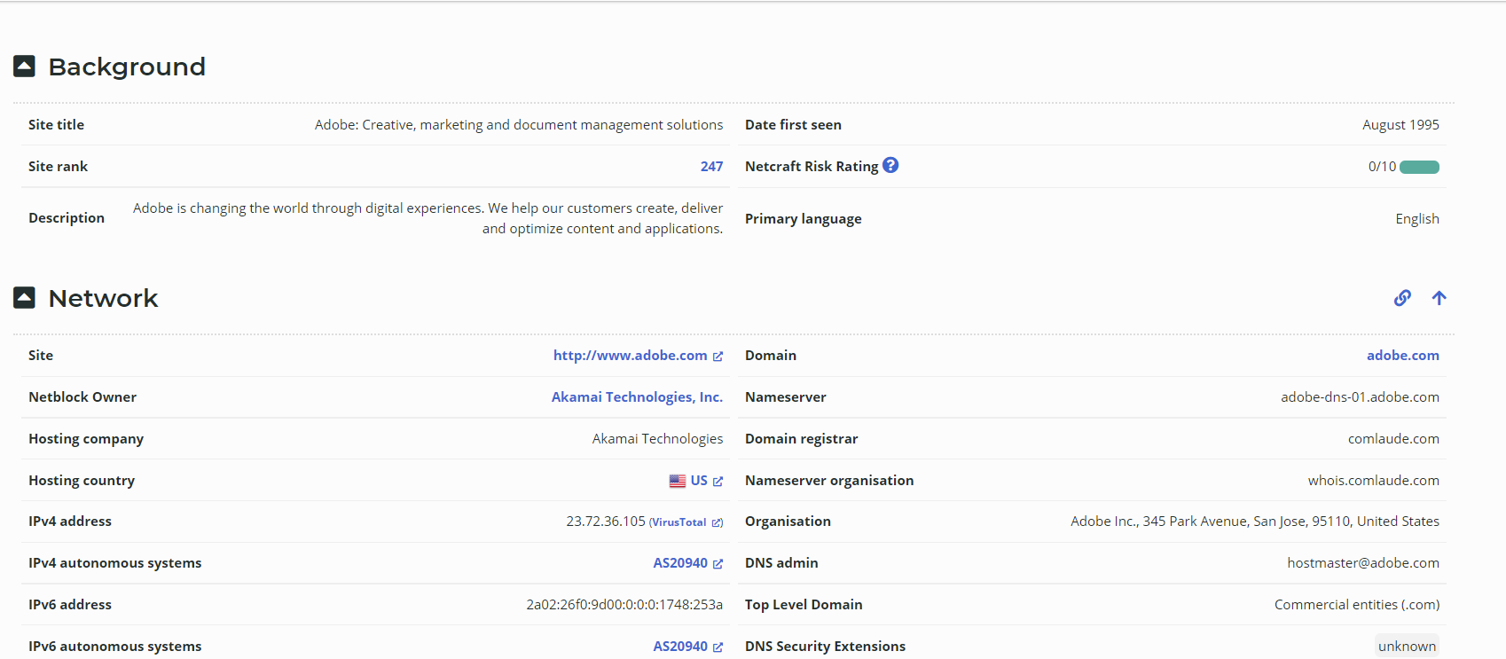

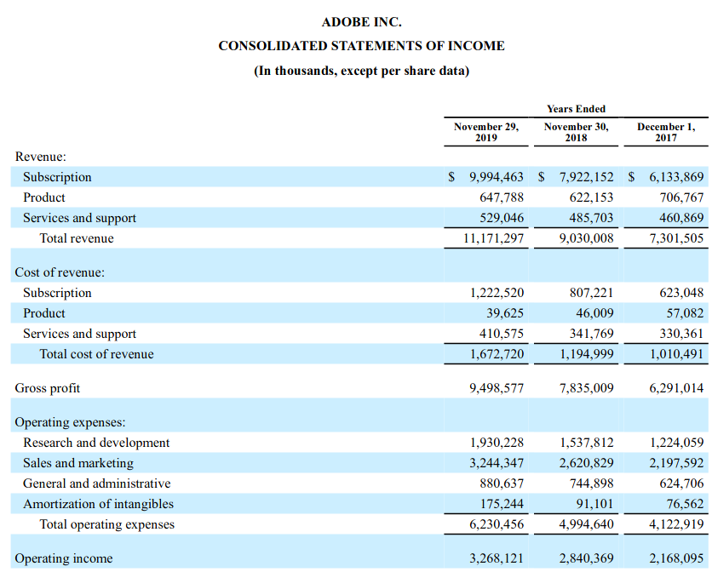

**List of directors and executive**

**inurl:adobe filetype:pdf intext:report**

<https://www.adobe.com/content/dam/cc/en/investor-relations/pdfs/ADBE-10K-FY19-FINAL.pdf>

**Executive Team**

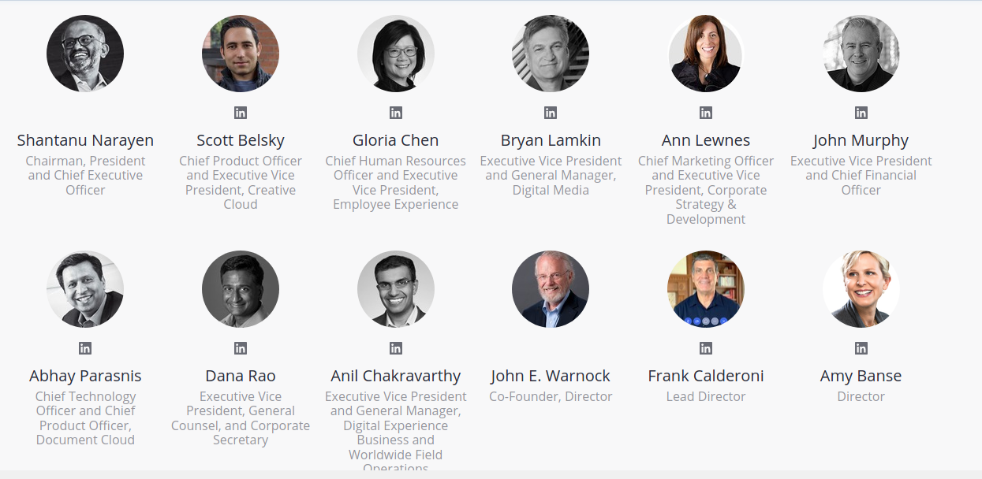

**Scott Belsky**

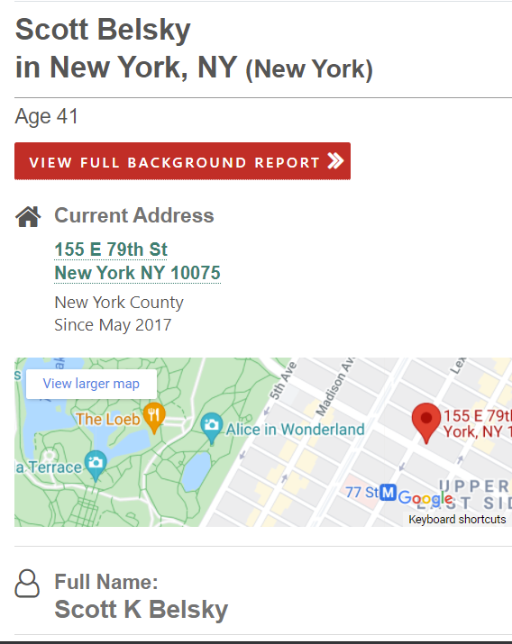

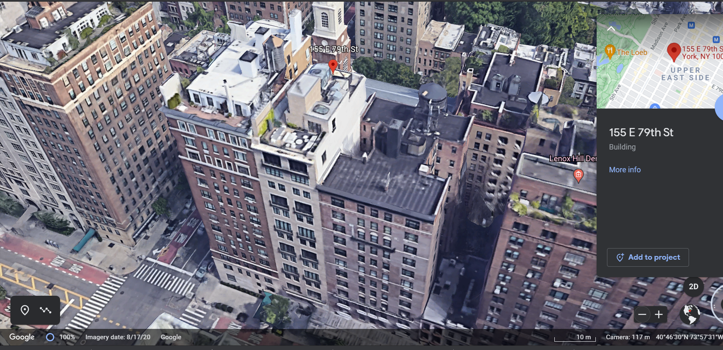

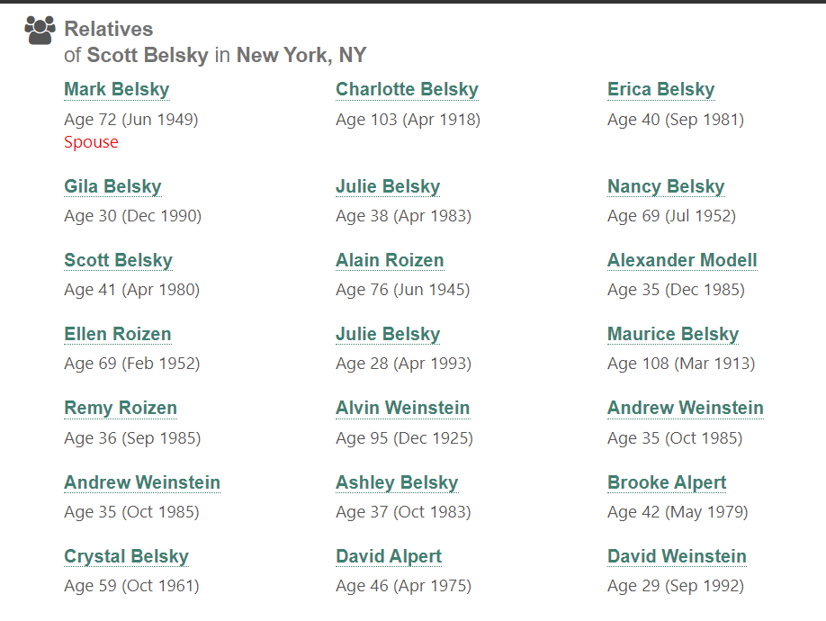

**Bryan Lamkin**

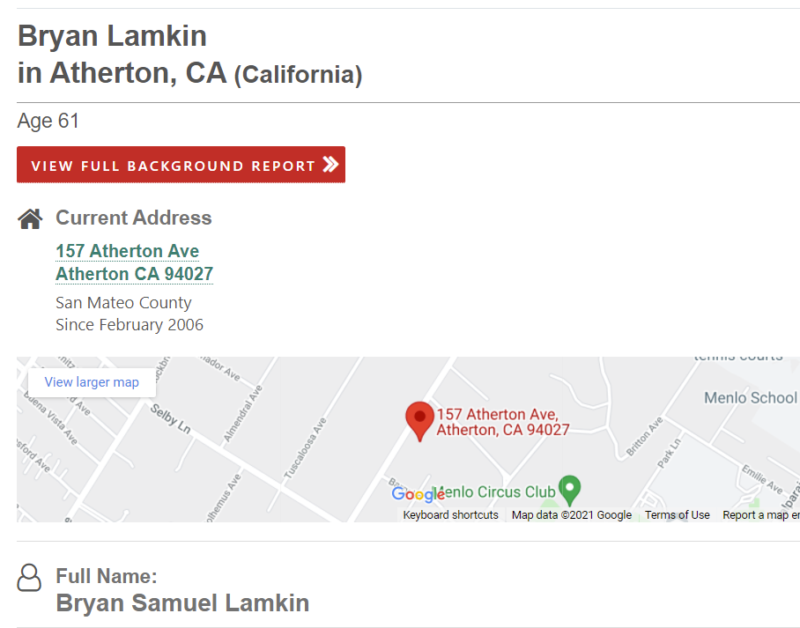

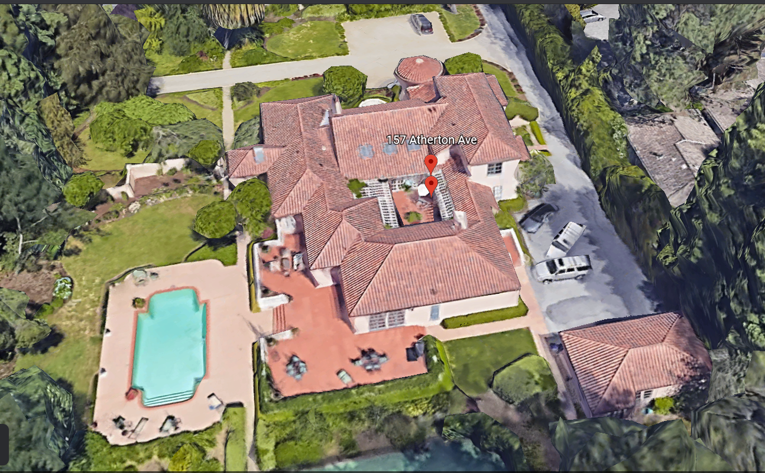

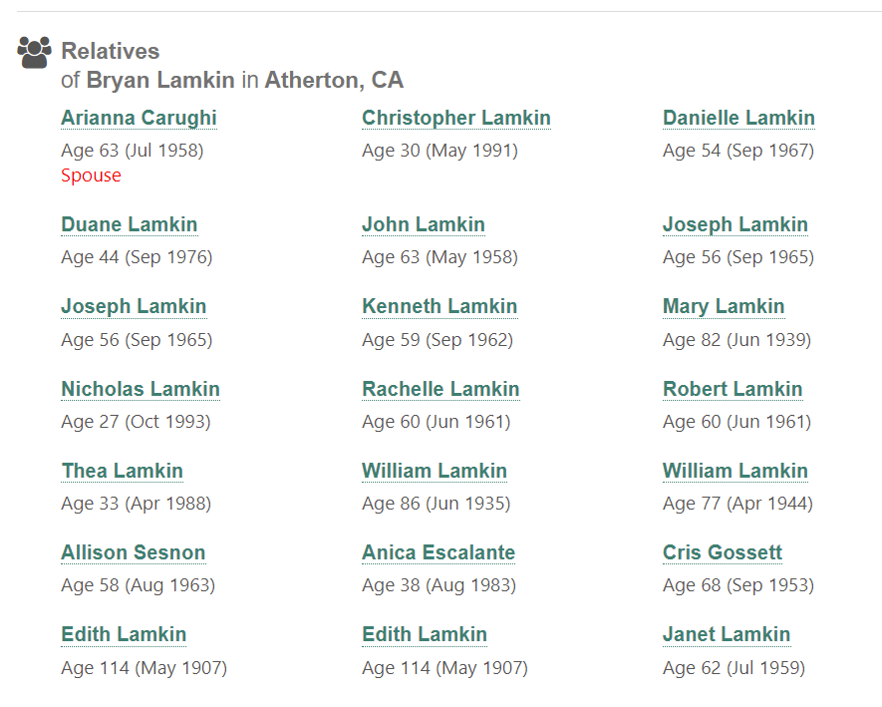

**Adobe Headquarter**

